Environment Setup Instructions

Table of Contents

2 Introduction 1

3 Steps to Complete 1

3.1 Create an IBM ID 1

3.2 Accept the IBM Cloud Invitation 1

3.3 Obtain your IBM Cloud API key 2

3.4 Connect to your watsonx.ai instance. 2

3.5 Clone the workshop Git repo 2

3.6 Ensure you have access to all the IBM Cloud services. 2

# Introduction

Complete the steps in this guide to ensure that you have the necessary IBM Cloud access.

# Steps to Complete

## Create an IBM ID

Register for an IBM ID using the instructions here: <https://www.ibm.com/account/us-en/signup/register.html>

## Accept the IBM Cloud Invitation

Accept the invitation from the IBM Cloud.

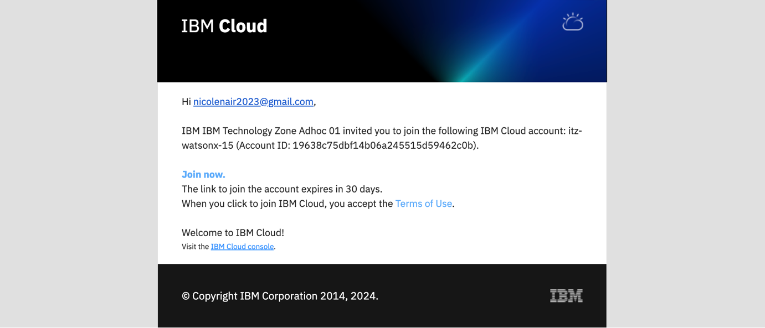

## Obtain your IBM Cloud API key

You will need your IBM Cloud API key for this lab. If you have an existing API key please us it or follow [these instructions](https://cloud.ibm.com/docs/account?topic=account-userapikey&interface=ui#create_user_key) to generate a new one in the [IBM cloud](https://cloud.ibm.com/). You will need this API key for next steps.

## Connect to your watsonx.ai instance.

Ensure that you can log into to [watsonx.ai](https://dataplatform.cloud.ibm.com/wx/).

## Clone the workshop Git repo

If you're a Github pro then you can directly clone this [watsonx.ai workshop repo](https://github.com/knijesh/GenAI_Incubation_watsonx/tree/main).

Otherwise, we recommend downloading and installing the [Github Desktop](https://desktop.github.com/) and then [cloning this workshop repo](https://github.com/nicolenairibm/wxgovernance-incubation). Here are instructions on [how to clone a repository using Github Desktop](https://docs.github.com/en/desktop/contributing-and-collaborating-using-github-desktop/adding-and-cloning-repositories/cloning-a-repository-from-github-to-github-desktop).

## Ensure you have access to all the IBM Cloud services.

Login in to ibm cloud account. Ensure you can see the following services for

1. Watson Studio
2. Watson Machine Learning.
3. Watson OpenScale

